14 | Design the following form  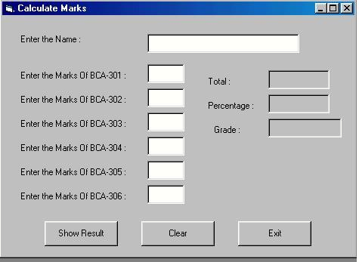
15 | Design a form to create conversion calculator like  - Decimal number to Binary, Octal & Hexadecimal.  - Binary number to Decimal, Octal & Hexadecimal.  - Octal number to hexa, binary ,decimal etc.
+16 | Design the following form. So when user clicks on Radio Button then select appropriate checkbox.  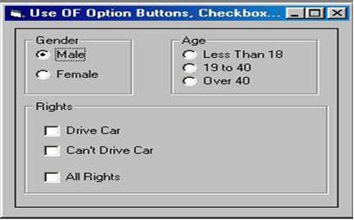
17 | program shows the functionality of listbox:  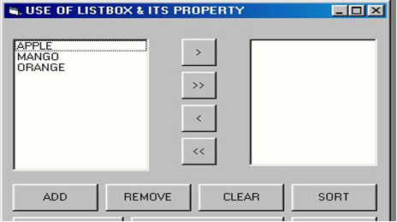
18 | Design one form to create application like Rich text document using 1 Rich Text box and different buttons. When user presses any of this command buttons then the selected content of Rich textbox will be changed accordingly.  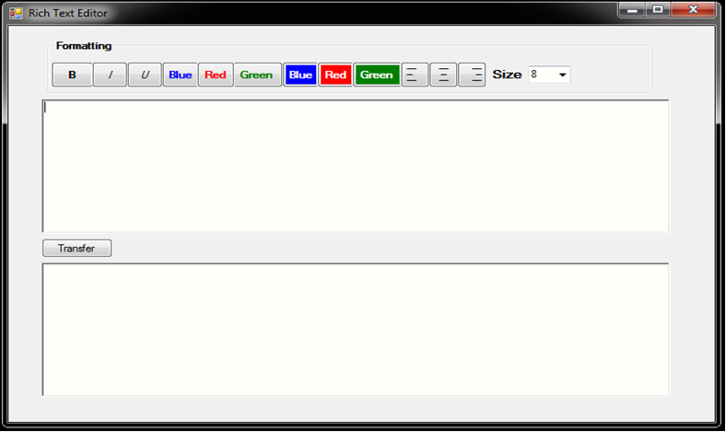
19 | Design the digital watch using Timer Control.  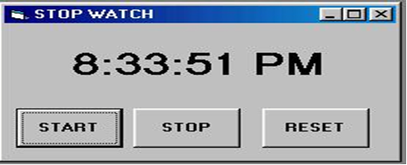
20 | Design the following form using horizontal scrollbar. In this, when user click on particular scroll bar then back color of shape will be changed to Red, Green & Blue color.  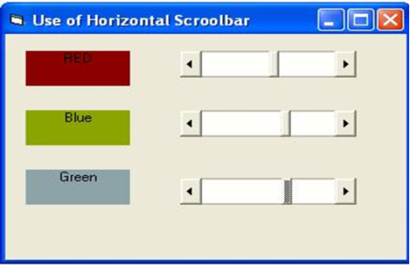
21 | Design the following form using vertical scrollbar. In this, when user click on particular scroll bar then back color of shape will be changed to Red, Green & Blue color.  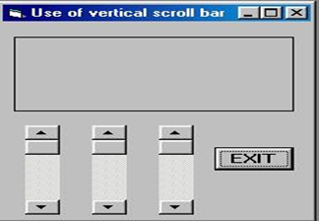
22 | Design the following Tic-tac-toe game.  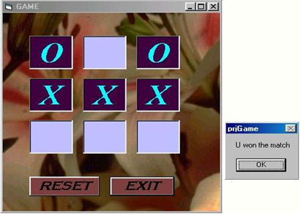
23 | Write a .Net console application to store student details in file and display it in console.
24 | Write a .Net window application to enter the student details in form with proper GUI component and store in a file and display in another form.
25 | Write an ASP.Net program to implement the validation controls.
26 | Write a console application to generate even and odd series.

